Useful function for numpy:

<https://numpy.org/doc/stable/reference/index.html>

Array creation:

Np.array([input array])

Np.zeros((row, col))

Np.eye(width of matrix)

Np.full((row, col), which value to fill in)

From file

Np.fromfile(file_source, count=how many elements to take, sep=use what to separate each element)

By interval

Np.arange(stop), np.arange(start, stop), np.arange(start, stop, interval) -> lst[:stop], lst[start:stop], lst[start:stop:interval]

Np.linspace(start, stop, num=”how many evenly splitted interval needed”)

Np.logspace(start, stop, num=”howmany evenly splitted LOG scale space is needed”, endpoint=False”if end points not included”) (1, 3, 3) -> only base 10 log ensures 3 evenly separated space -> outputs 10, 100, 1000 -> log_10(10), log_10(100), …

Np.geomspace(start, stop, num=”how many elements to display, by exponential power”, endpoint=) (1, 32, 6) only exponential of 2 allows 6 evenly separated space between 1 and 32

Outputs 0, 1, 2, 3, 4, 5 -> 2^0=1, 2^5=32…

Np.diag(1-D-array), Np.diag(2-D-array); construct diagonal matrix using 1D, extract diagonal from 2D.

Array indexing

Basic indexing:

X[start:end:interval], X[:, start:end:interval, start:end:interval, …], X[…, start:end:interval, :, :],

X[…, :, :, :], …

First is for 1D indexing, second is for multi-dimensional indexing, with only 2nd and 3rd axes’s range being restricted; third is the indexing of everything except last 3rd axis is restricted; fourth is the index of every elements.

Advanced indexing:

X[[row1, row2, …row_n], [col1, col2, …col_n]] -> [(row1, col1), (row2, col2), ….(row_n, col_n)].

X[ [[rowi, rowj, rowk],

[rowl, rowm, rown]],

[[coli, colj, colk],

[coll, colm, coln]] ] ->

[ [(rowi, coli), (rowj, colj), (rowk, colk)],

[(rowl, coll), (rowm, colm), (rown, coln)] ]

Array operations

Shape and axis

Shape: (a, b, c, d, …) the order of shape indicates for the ndarray, “a” indicates outer-most dimension ->

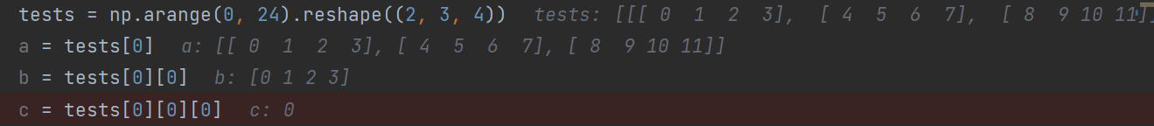

Np.reshape(nparray, (new row, new column)) both arrays should have same amount of elements, or an error would occur

Ndarray.flatten(optional[order]) collapse a 2D array into 1D (refer to 28*28 images convert to 784 pixels)

Order: ‘C’-row by row append, ‘F’-col by col append, (‘A’, ‘K’ not used frequently)

Ndarray.T transpose of array, same to linear algebra

Np.swapaxis(ndarray, axis1, axis2) -> a 3D array would have axis (0, 1, 2). Realizing this function works for axis > 2

Convert to array

Np.asarray(array)

Np.asmatrix(array)

Np.asscalar(array with size 1)

Np.asfarray(array) -> convert array to np array of float values

Array combination and splitting

Np.concatenate((ndarray1, ndarray2), axis=) -> axis is 0 if add array2 at bottom row and 1 if right-most column, axis=none to flatten combination of ndarray1 and ndarray2; both ndarray must have same “side length” according to concatenation axis;

Np.stack(Union[ndarray, (ndarray1, ndarray2)], axis=) -> input 1: rearrange all ndarray[i]’s element along “axis”; input2: concatenate two ndarrays along “axis”; two arrays must have same “side length”

**Warning: this method always pile up data to form a new dimension;**

**Requiring all inputs to have exact same shape, and “axis” only affects at last two dim;**

**Above warning doesn’t apply to hstack, vstack or dstack.**

* Note: for 3D cases, could be convenient to use: np.vstack((nparray1, nparray2)) to replace axis=0, np.hstack((nparray1, nparray2)) to replace axis=1, and np.dstack((nparray1, nparray2)) to combine two arrays, by creating a third dimension. 

Np.split(ndarray, Union[int, array[int]], axis=”0 by default”) -> if “int” is given, will split the array evenly by “int many”, but requires “divisibility (a|b)”; if array[int], then will split the array by “index in array[int]”(index exceeding len(ndarray) result in subsequent empty ndarray).

Np.array_split(ndarray, int, axis=0 for default) -> same as np.split(ndarray, int, axis=) “except” ‘divisibility’ is no longer required.

Adding and modifying array elements

Np.delete(ndarray, obj, axis=None) -> obj: a int or an array of int, as an index. axis: 0 for deleting rows, 1 for deleting columns, None for deleting “flattened” array’s elements (returns “flattened” array)

Reference of “MASK: boolean ndarray; (np[mask])”

Np.insert(ndarray, obj, value, axis=None) -> returns a new array, input doesn’t change

obj: index to insert (new element will have the index after insertion), a scalar or int

array. Obj cannot exceed number of elements along an axis (if this number is given,

same as append along that axis)

Value: if a scalar, will insert a row/col/one value depending on shape of ndarray; if an array list, will insert according to “axis”(requiring shape-consistency).

Axis=None will first “flatten” ndarray, and return “flattened” one.

(insert considers type-casting: float->int, boolean -> int for ndarray[int])

Np.append(ndarray, value, axis=None) -> must maintain shape-consistency before appending,

Np.unique(ndarray, return_index=False, return_inverse=False, return_counts=False, axis=None)

(return an array of unique elements in SORTED ORDER)

* Return_index: if True will return each unique element’s first apparence in ndarray, in the form of an ndarray.
* Return_inverse: if Ture, will return index array having length to input ndarray, each element is the corresponding index of element in returned unique list. -> unique_array[index] will give original input “ndarray”
* Return_counts: if true, will return an array “count” where “unique_array[i]” appeared in “ndarray” for “count[i]” many times.
* Axis: refer to previous discussions

Np.flip(ndarray, axis=None) (revert elements according to axis)

* Axis: if None ,will revert elements in flattened array (but returned array has same shape as input)

If is an int, just revert by the indicated axis.

If a tuple of int, will revert by all those axes.

Np.flipud(ndarray) -> up and down -> same as np.flip(ndarray, axis=0)

Np.fliplr(ndarray) -> left and right -> same as np.flip(ndarray, axis=1)

Np.reshape(ndarray, (new_shape[0], new_shape[1]) , order=’C’ by default)

Requiring new shape has the “SAME” number of elements as input;

First flatten ndarray, then re-construct according to given new shape -> not equal to “transpose”

* (int, int) as new shape. First int is num of rows
* Order: C: filling inner-layers first; ([[a]] [[a, b]]); F: filling outer-layers first [[a]] [[a], [b]]

Sorting, searching

Numpy.sort(ndarray, axis=-1, kind=None, order=None):

Return a sorted copyof “ndarray”

Kind: {‘quicksort’, ‘mergesort’, ‘heapsort’, ‘stable’}

Realize:

Sorting along last axis doesn’t consume extra space when sorting;

(might be useful if swapaxis is used before sorting for space saving?)

Numpy.argsort(ndarray, axis=-1, kind=None, order=None):

Return INDICES that would sort “ndarray”.

Ndarray.sort(axis=-1, kind=None, oeder=None):

IN-PLACE sorting of “ndarray”

Numpy.partition(ndarray, kth, kind=’introselect’):

Return a new array with partition as follows:

The element at index “kth” of output array is the element in “ndarray[kth]” after sorting

Any elements at index < “kth” are all less than “ndarray[kth]”;

‘introselect’: the algorithm for performing partition;

Basically it performs similar technique as quicksort/heapsort depending on efficiency of which algorithm is faster.

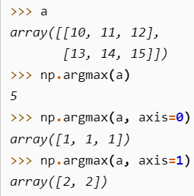Numpy.(nan)argmax(ndarray, axis=None, out=None, )

Return the INDICES of maximum values along an “axis” for “ndarray”.

If “axis” is none, will flatten “ndarray” and return the flattened max’s indice

Out: if given, the output of this method will be filled into “out” ndarray.

It must have the appropriate shape to contain the result.

“nan” is ignored if “(nan)” is included, “ValueError” is raised if “ndarray” is all-nan;

Numpy.(nan)argmin(ndarray, axis=None, out=None, )

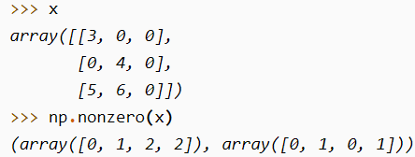Numpy.nonzero(ndarray):

Return all indices, following the form: array(dim0_indices, dim1_indices, ….) where the indexed elements are non-zero.

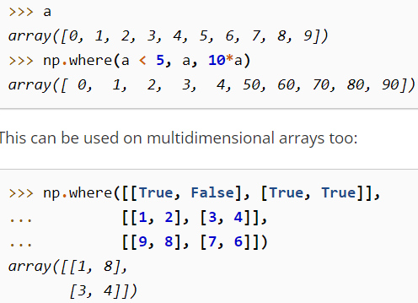Numpy.where(condition, x, y):

Returns a new ndarray, where when “condition”’s indices is true, corresponding output indice will be “x”’s corresponding element. Otherwise the output’s corresponding indice will be “y”’s corresopnding element.

Image shown right shows what can condition be:

boolean expression or a True/False array.

Datatype operations

<https://numpy.org/doc/stable/user/basics.types.html> numpy’s data types

Np.can_cast(source, destination) ->

* Both source and destination can be: type (np.float, float) and attributes or mix of both: -> (np.float, float), (1000, boolean)…

Np.emath package:

Np.sqrt(x), np.log(x), np.log2(x), np.logn(n, x), np.log10(x), np.power(x, p), np.arccos(x), np.arcsin(x), np.arctanh(x)

Functional programming: Apply a function to all elements of an array

Np.apply_along_axis(func_name, axis:int, ndarray, ) -> returns a new array

“func” must accept 1D array; once this method is called, it will extract ndarray along axis as 1D array and transfer to “func”.

If “func” returns a higher dimensional array, then the position of 1D array in ndarray will be replaced by the higher dimensional array.

Np.apply_over_axis(func_name, ndarray, axis: array-like) -> returns a new array

“func” must accept 1D array as input; will implement operations on axes one by one in “axis” array.

Np.vectorize(function) -> return a function which could be applied on vectors;

“function” can only be applied on SCALARS!!! When need to use the vectorized function, simply call it and give ndarray and scalars as input.

Np.piecewise(input-variable, [boolean-condition1, boolean-condition2, …], [func1, func2,…]) ->

return element has same dimension as input-variable

Boolean-condition must be based on “input-variable”, and usually use inequalities;

(useful for creating activation function)

Advanced indexing using indices and masks

Indexing:

Np.where(condition, array1, array2) -> return a new array

“Condition” is a statement placable after “if”; applied on “array1”

If condition on array1’s current element returns true, take an element from array1;

If condition is false on array1’s current element, take array2’s corresponding element

Array1 and array2 must have same shape for 1-1 correspondence.

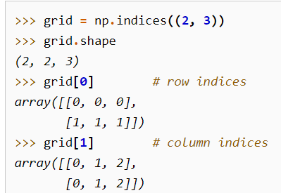

Np.indices((shape1, shape2, shape3, …shapen)) -> return a ndarray

Indices will return a (n, shape1, shape2, …shapen)’s ndarray, where “n” indicates the axis of ndarray, and for each shape1, ….shapen, each element represents index along shape1’s axis, …shapen’s axis.

Can be used for indexing a real array.

Np.ravel_multi_index(ndarray, (shape)) -> return the represented index of

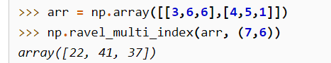flattened (shape) array

this method treats ndarray as an “index array”, as described in “ARRAY-INDEXING” part and returns corresponding flattened (shape) array’s index.

Np.unravel_index(1Darray, (shape)) -> return a ndarray of indices on (shape) array.

This method does exactly the opposite as ravell_multi_index

Np.mask_indices(int, mask_function, k) -> returns a boolean array

“int” means the generated boolean array can apply on array with shape (int, int)

Mask_function: func(input_array, k) returns a boolean array.

K: argument for mask_function.

Used for generating masked-indexes for array creation.

Np.diag_indicies(int, optional[ndim]) -> return ndim many arrays with shape (1, int)

Used for indexing the diagonal elements of an array having (ndim, int, int) shape.

Extracting elements according to advanced indexing

Np.take(ndarray, indices, axis=None) -> return a new ndarray being indexed by given “indices”

Equivalent to ndarray[:, :, …:, indices, :, :…] where “indices” locates at “axis” position

When axis=None, indices will be flattened before using

Once a indices (with int element) is given, each element of that indice would represent a

ndarray[:, :, …:, indice_element] ndarray. This array will fill that element’s position in

indices array.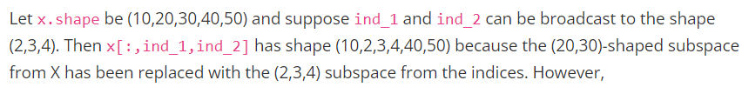

np.choose(array1, array2) -> return a newly created array

“array1” needs to have same length as outer-dimension of “array2”.

“array1” must be 1D.

In practise, the newly constructed array will have “array2[array1[i]][i]” as “ith element”.

Np.select(condlist, choicelist, default=0) -> return a new array extracted according to condlist

Condlist is a 1D-list of conditions, each applied on elements of choicelist.

Choicelist is a list of ndarrays. The ordering of choicelist’s elements affects ordering of

evaluation.

Default is the value to fill if no elements at given index from any choice-ndarray satisfies

condlist.

In practise, if 1st ndarray in choicelist doesn’t satisfy any condition in condlist, will move

on to 2nd, …and so on.

Np.compress(condition, ndarray, axis=None) -> return a new array

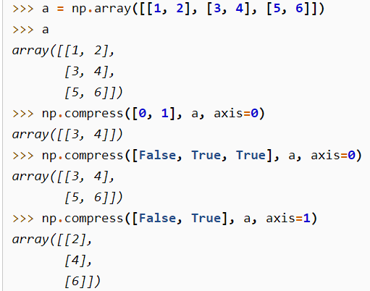Condition: a boolean ndarray; if condition has less length than ndarray.shape[axis], will only output “len(condition)” dimensional ndarray along “axis”.

Axis: the axis where condition would be applied to extract elements out;

Axis=None: will flatten ndarray first

Adding elements according to advanced indexing

Np.place(ndarray, mask, vals) -> return None

Replaces ndarray’s elements according to mask-conditions;

Mask must be a boolean expression applied on “ndarray”;

Vals will be replaced consecutively and cyclic -> 1st occurrence of false: replace with

val[0], …. And a cycle if all elements in “vals” is done replacing in ndarray for a cycle

np.put(ndarray, indices, value-to-replace) -> return None

**warning: indices are for flattend array only!!!**

replaces ndarray’s element into “value-to-replace” based on indices

indices can be indexing array or boolean array

value-to-replace will be done consecutively and cyclic.

Np.put_along_axis(ndarray, indices, values, axis) -> return None

Indices: the “indices” of sub-ndarray along arrays, must have same depth as “ndarray”.

Must also be a type “ndarray”.

Value: can be a scalar or ndarray value, requires shape to be boardcastable.

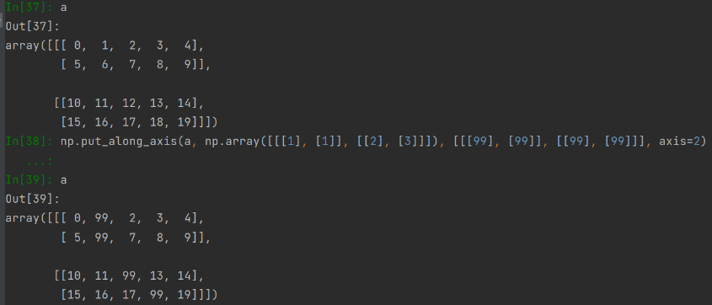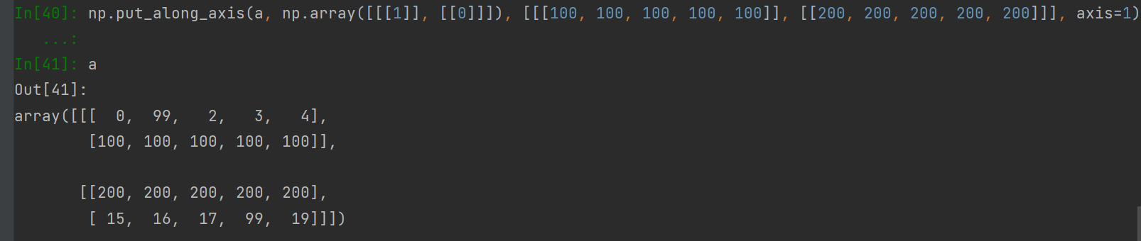**Indices must have the same dimension as ndarray, and value must have same dimension as the “ndarray” about to be replaced, depending on axis, and how many to be replaced.**

Np.putmask(ndarray, mask, values) -> return None

Mask: boolean array, must have same shape as ndarray

A value will be replaced only when element-mask is “True”

Values: can be a scalar or array-like; values will be replaced consecutively and cyclic.

Linear algebra: np.linalg from numpy import linalg as lin

Multiplications

Lin.dot(a, b) -> return dot product of two arrays as a new array

“a” and “b” must satisfy shape restriction for matrix/vector multiplication.

Using “@” (a @ b) is preferred for “Matrix multiplication”

(supports scalar multiplication as well)

Lin.multi_dot(arrays) -> return matrix-multiplication of multiple vectors in “arrays”

Arrays: a sequence of vectors/matrix for multiplication

All arrays must be 2D except 1st and last, treated as row-vec and col-vec respectively

Lin.vdot(a, b) -> dot product of two vectors

Lin.inner(a, b) -> inner product of two arrays (a1*b1+a2*b2+…)

Lin.outer(a, b) -> outer product of two arrays (two vectors -> one matrix)

Useful for creating COVARIANCE MATRIX, where two inputs are variance of each X^{->}.

Lin.matmul(a, b) -> matrix product of two arrays

Require a, b satisfy shape constraints, and will perform matrix multiplication.

Equivalent to “a @ b”

Lin.matrix_power(a, n) -> return the result of matrix multiplication of “n” many “a”.

“a” is required to be a square matrix

If “n” is 0 will return identity

Np.multiply(a, b) -> elementwise multiplication of two matrix/vector/…

Requires “a, b” to have same shape

Special_values

Lin.eig(a) -> return (array1, array2)

Suppose “a” has shape (n, n)

Array1 is the array of eigenvalues, with dimension (…, n)

Array 2 is the array of eigenvectors with dimension (n, n)

Array2[:i] corresponds to array1[i]

Lin.norm(a) -> return norm of a matrix / vector

Lin.det(a) -> return square matrix “a”’s determinant

Lin.matrix_rank(M) -> return rank of matrix M

Lin.trace(a) -> return the sum along diagonal of array

Linear solver:

Lin.solve(a, b) -> solve equation ax=b and return “x”

Lin.lstsq(a, b) -> find a best fit line for y=mx+c;

Given a set of points{(**x**, y)}, generate “a” as follows: a = [**x** 1] (last col contains only 1)

And solves equation “y = ap” where p is: [[m], [c]] by letting “a” = a, “b” = y.

Returns “p” containing “m” and “c” for best fit line

Lin.inv(a) -> compute inverse of matrix “a”

Matrix operations: np.matlib

Np.asmatrix(ndarray): interpret input as a matrix;

Realizing the shape has to be 2D (or an error would occur)

**From numpy import matlib**

matlib.zeros(shape): returns a new matrix with given shape;

shape: a sequence with length AT MOST 2!!!

Matlib.eye(n, M=None, k):

n: number of rows in output matrix;

M: number of columns in output matrix;

K: index at diagonals (refer to “diag” in some pytorch methods);

Matlib.rand(shape_tuple)

Shape_tuple: a size 2 tuple;

Matlib.randn(shape_tuple): generated matrix have values sampled from a normal distribution

with mean 0 and std 1;

random normal distribution can be acquired by:

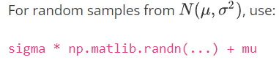

Matlib.empty(shape), matlib.ones(shape), matlib.identity(n: square matrix size),

Masked array package import numpy.ma as ma

Most operations which can be performed on a normal array can also be performed here, ignoring masked value whenever possible.

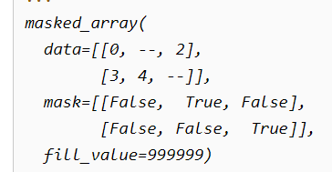

Example on the left shows properties of a masked array OBJECT.

Elements with “--” in “data” is where mask is applied (“true” in mask).

“fill_value” indicates what value to give when convert back to original array.

Creation and examination

Ma.MaskedArray(data, mask=boolean_ndarray) -> returns a masked array with all properties

“data” and “boolean_ndarray” must have same dimension.

Ma.masked_all(shape) -> return a masked array where all elements are masked.

Shape is a tuple of integers.

ma_ndarray.all() -> returns true if all elements in “ma_ndarray” are masked.

.any() -> if ant element in “ma.ndarray” is masked.

ma.count_masked(ma_ndarray, axis=None) -> count how many elements are masked.

If axis=None, the count flattened version and return a scalar.

If not, will return a “ndarray” where each element indicates how many “ma_ndarray”’s elements are masked along that axis.

mask out values

Ma.mask_cols/rows/rowcols(ma_ndarray) -> return a modified ma_ndarray as follows

**ma_ndarray is 2D**

If there is a mask at a column/row/location, then all entries of that

column/row/row&col will be applied with a mask

ma.masked_invalid(ndarray) -> mask a location of “ndarray” whenever “NAN or INFs” occurs

ma.masked_equal/greater/greater_equal/less/less_equal/not_equal(ndarray, value) -> return a ma_ndarray according to follows:

A mask is applied to a value in “ndarray” whenever the value is “equal/greater/greater_

equal/less/less_equal/not_equal” the “value”.

Ma.masked_value(ndarray, value, copy=True):

mask entries from “ndarray” where the entry is equal to “value”.

Copy: whether to return a new copy of masked array(same as inplace)

Ma.masked_inside/outside(ndarray, v1, v2) -> return a ma_ndarray as:

If the current element in “ndarray” is inside/outside interval “[v1, v2]”.

Ma.masked_where(condition, ndarray) -> return a ma_ndarray as:

If the current element in “ndarray” meets with all conditions in “condition”.

“condition”: a 1D array, with expressions producing true/false. Applied on “ndarray”.

Other similar functions to ndarray operation: all functions applied on ma_ndarray, with masks combined, masked_elements ignored in math calculations.

Concatenate, stack, vstack, hstack, dstack, append;

Mathematical operations:

**All operations require adding “np.” at front;**

Np.sin(ndarray), cos(ndarray), tan(…), arcsin, arccos, arctan, sinh, cosh, tanh, arcsinh, arccosh, arctanh

Degree(x: radian)<->radian(x: degree)

Floor(numeric), ceil(numeric),

Sum(ndarray, axis, keepdims, ), prod(ndarray, axis, keepdims)

Nansum(ndarray, axis, keepdims), nanprod(ndarray, axis, keepdims)

Nan values are treated by “0” in “sum” and “1” in “product”

Cumprod(ndarray, axis), cumsum(ndarray, axis):

Each entry of returned array is the sum of all previous elements along a given axis

Nancumsum(ndarray, axis), nancumprod(ndarray, axis)

Diff(ndarray, n=1, axis=-1, [prepend, append]):

For each indices “i” (1D as an example), calculate the value “ndarray[i] – ndarray[i-n]”, along given “axis”;

Prepend/append: values to append to “ndarray” before performing operations;

Realizing if “n=1”, there are at most “n-1” many calculations available;

Thus require prepend/append to fill in the value.

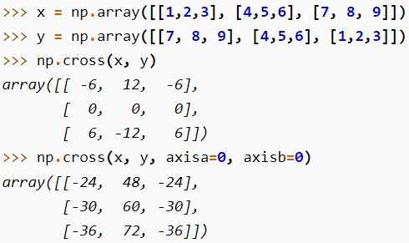Np.cross(ndarraya, ndarrayb, axisa=-1, axisb=-1, axisc=-1, axis=None)

Axisa: determines which dimension of ndarraya should be treated as vectors;

Axisc: determines which dimension of the output ndarray represents cross product result.

Axis: if defined, will overwrite axisa, axisb and axisc (replacing all 3 values with “axis”)

Image on left gives better understanding of axis;

Exp, log, log10, log2, exp2;

Arithmetic operations:

Add(ndarray1, ndarray2): adding elements ELEMENTWISE;

Requiring ndarray1 and ndarray2’s shape to be boardcastable.

Reciprocal(ndarray): returns reciprocal of elements in “ndarray”, elementwise. 1/x

Multiply(ndarray1, ndarray2): perform multiplication operations elementwise;

Ndarray1 and ndarray2’s shape must be boardcastable;

Divide(ndarray1, ndarray2)

Power(base_ndarray, power_ndarray):

Raise elements from “base_ndarray” by corresponsing power from “power_ndarray”;

Require shape-boardcastble

Nanmax(ndarray, axis, keepdim), nanmin(ndarray, axis, keepdim):

Take max or min while IGNORING “nan”

Sqrt, absolute, sign,

Nan_to_num(ndarray, copy=True, nan=0.0, posinf=None, neginf=None):

Replace all “NAN” value in “ndarray” to “nan” in parameter,

Positive infinity to “posinf”, negative infinity to “neginf”;

All three parameters should be a finite number.

**From numpy.polynomial import Polynomial**

Polynomial(coef=[a, b, c, …. z], domain=None, window=None):

Create a 1D polynomial “Y = z x26 + y x25 + … + c x2 + b x + a”;

Window: the window to use; given [domain[0], domain[1]], the region is shifted and scaled to region [window[0], window[1]].

Cov, cumsum, mean, median, power, prod(product), std, sum, var, argmax, argmin, max, min, sort, diag,

dot, identity, inner, outer, trace, transpose.

Random:

Np.random.seed(int);

Np.random.Generator.integers(low, high=None, size=None, endpoint=False)

Generate integers following a uniform distribution;

if “high” is not given, digits will be generated from zero to “low”;

size: tuple of output ndarray shape; will generate enough integers to fill the ndarray;

if not given, will generate a single integer;

endpoint: if True, “high” will be possible to generate;

np.random.Generator.random(size=None, )

generate float points in the interval [0.0, 1.0), following a uniform distribution;

can use shift-and-scale to get any desired interval;

Np.random.Generator.shuffle(ndarray, axis=0)

Np.random.Generator.permutation(x, axis=0)

**Distribution generators:**

Np.random.Generator.binomial(n, p, size=None)

n: # of trials, the key parameter for binomial distribution;

p: the probability, another parameter for binomial distribution;

other supported distributions: (for specific usage see API reference)

np.random.Generator.chisquare/exponential/gamma/geometric/logistic/multinomial/normal/poisson/uniform

Statistics:

Percentile & quantile

Numpy.(nan)percentile(ndarray, q-array, axis=None, out=None, overwrite_input=False, method=’linear’, keepdims=False, )

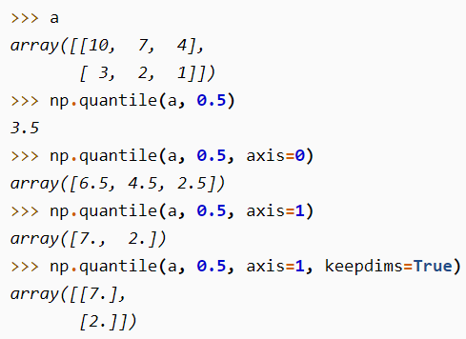Percentile: returns the observations/samples/values… that, other observations /values/… below the returned one, altogether can be ovbserved for a probability of “p%”

q-array: the ndarray containing percentiles; (integers between 0 and 100)

if “axis” is not given, will flatten “ndarray” and perform operations

out: alternative output array for filling the result.

The output, regardless of given one or returned one, should match with the dimension of “q-array”.

Overwrite_input: allowing “ndarray” to be modified during calculation, for saving space(but “ndarray” would no longer be used; )

Nan: if “nan” is prefix, will ignore “nan” values in array.

Numpy.(nan)quantile(ndarray, q-array, axis=None, out=None, overwrite_input=False, method=’linear’, keepdims=False,)

Quantile: squivalent to percentile, but with “q-array” values between 0 and 1;

Statistical evaluations:

Numpy.median(ndarray, axis=None out=None, overwrite_input=False, keepdims=False)

Numpy.average(ndarray, axis=None, weights=None, )

Weights: for calculating weighted average. Can be 1D array or with same shape as “ndarray”. Realizing the 1d shape must match with “ndarray AND axis”.

Numpy.mean(ndarray, axis=None, out=None, keepdims=bool[optional], where=bool[optional])

Calculate equally-weighted average of “ndarray”

Numpy.std(ndarray, axis=None, out=None, ddof=0, keepdims=bool[optional], where=bool[optional])

Ddof: when calculating standard deviation, the denominator has the form “N-ddof”, where “N” is the sample amount. One example of using “ddof” is 1, “N-1”;

Numpy.cov(m, y=None, rowvar=True, bias=False, ddof=None, fweights=None, aweights=None,)

M: 1D or 2D array, when “rowvar” is true, will treat each row as a single variable, and each element in the row as observation. (if False, then opposite.)

Bias: if “True”, the denominator of calculating std is “N”, instead of “N-1” when bias=F

Fweights: frequency weights 1D vector; (currently not commonly used)

Aweights: 1D observation vector weights; (currently not commonly used)

Numpy.histogram(ndarray, bins=10, range=None, )

“ndarray” will be flattened for computing histogram

Bins: the number of bins for the histogram graph;

If input is a sequence instead of a scalar:

[0, 1, 4, 5]: the second bar will have width “3”;

Range: if not provided, histogram will plot for data from “ndarray.min()” to “ndarray.max()”; if provided: (float, float)